PROGRAMM:

<html>
<head>
<title>Text Formate Tags</title>
</head>
<body>
<b>kavitha</b><br>
<i>college of engineering</i><br>
<u>information tchnology</u><br>
<pre>web programming</pre><br>
<big>structure</big><br>
<small>html</small><br>
<strong>document</strong><br>
<mark>kavitha</mark><br>
<br>basic<br>
<tt>basic</tt><br>
ax<sup>2</sup><br>
H<sub>2</sub>o<br>
<b><font color="blue" size=15> Text Formate Tags</b></font>
<h1 style="font-size:300%;">this is heading</h1>
<p style="font-size:155%;">this is a paragraph</p>
<h1 style="text-align:center;">Centered Heading</h1>
<p style="text-align:center;">Centered paragraph.</p>
</body>
</html>

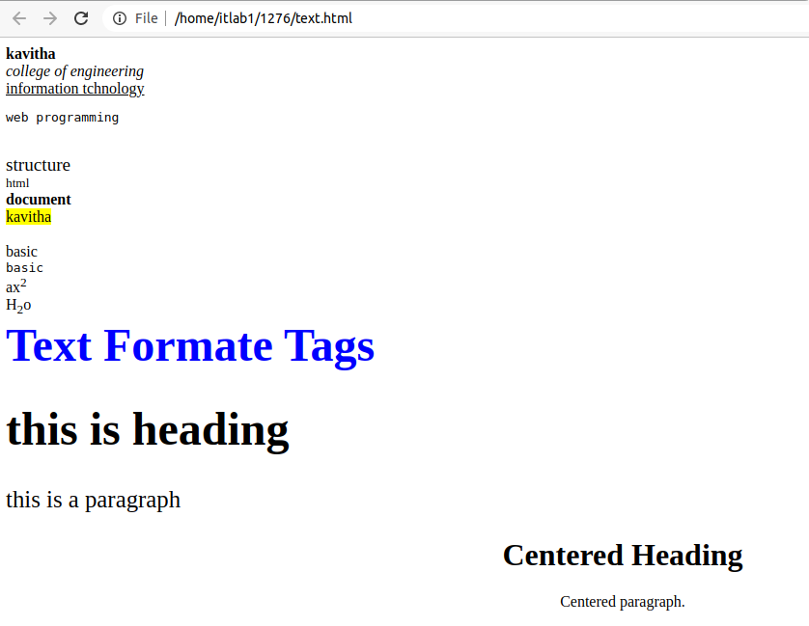
OUTPUT:

